Find the Outliers:

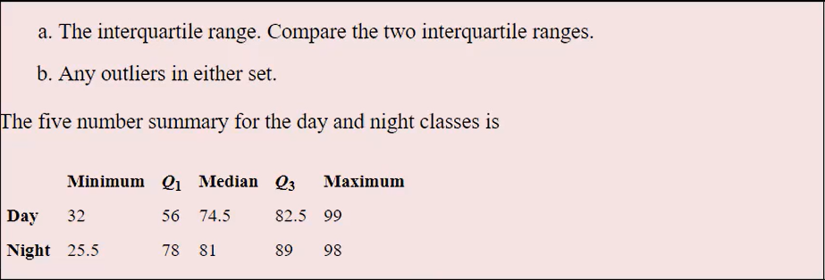

Day

IQR = Q3 - Q1 = 82.5-56 = 26.5

1.5 * IQR = 39.75

Lesser Outlier range = Q1 - 39.75 = 16.25

Greater Outlier range = Q3+39.75 = 122.25

There are no outliers present in Day class.

Night

IQR = Q3 - Q1 = 89-78 = 11

1.5 * IQR = 16.5

Lesser Outlier range = Q1 – 16.5 = **61.5**

Greater Outlier range = Q3+16.5 = 105.5

**There are lesser outliers present in Night class because the minimum value in this class is 25.5**

Outliers Handson is below

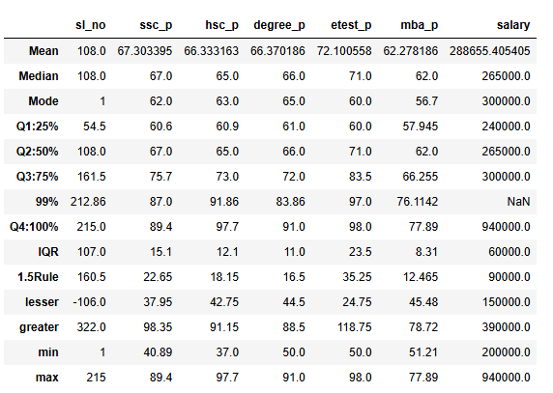

ssc_p:

No lesser outlier because minimum value 40.89 > lesser range 37

No greater outlier because max value 89.4 < greater range 98

hsc_p:

**lesser outlier is present because minimum value 37 < lesser range 42**

**greater outlier is present because max value 97.7 > greater range 91**

degree_p:

No lesser outlier because minimum value 50 > lesser range 44

No greater outlier because max value 91 < greater range 88.5

etest_p:

No lesser outlier because minimum value 50 > lesser range 24.5

No greater outlier because max value 98 < greater range 118.75

mba_p:

No lesser outlier because minimum value 51.21 > lesser range 45.48

No greater outlier because max value 77.89 < greater range 78.72

Salary:

No lesser outlier because minimum value 200000 > lesser range 150000

**Greater outlier is present because max value 940000 > greater range 390000**